Notes about Metallic Bonding & Structure

Part of the giant structure of atoms in aluminium
Metal atoms packed regularly

Metal ion which forms on delocalisation of electrons

Metallic bonding

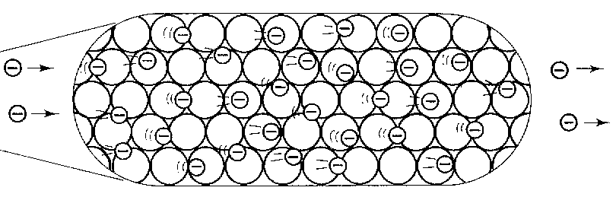
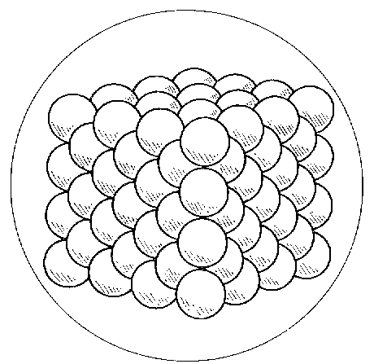

Strong metallic bond

Delocalised electrons from outer shell of metal atoms

Properties of metals | Reasons
High melting point  (tend to be solid at room temperature) | The strong metallic bond between delocalised electrons and positive metal ions requires a lot of energy to break.
Conducts electricity | The delocalised electrons are both mobile and charged and these electrons carry the current. (note: the delocalised electrons are also the reason for good thermal conductivity)
Malleable (and ductile) | The positive metal ions are arranged in layers. The layers are able to slide over each other. The layers can slide without the metallic bond breaking because the electrons are free to move too.

